EENG 385 - Electronic Devices and Circuits
PID Controller
Handout

PID Controller
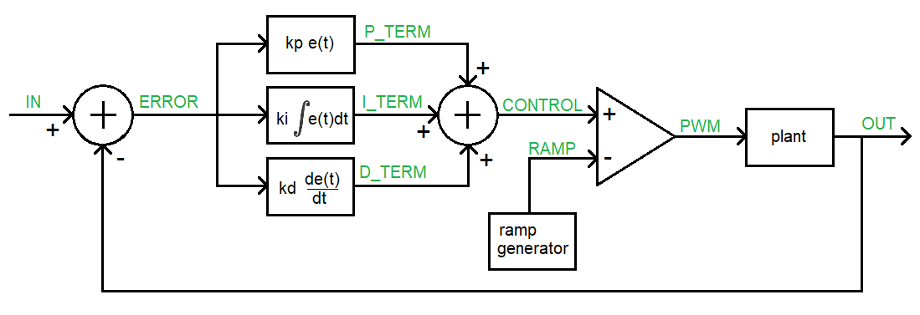
Figure 1: High-level architecture of the PID Controller board.
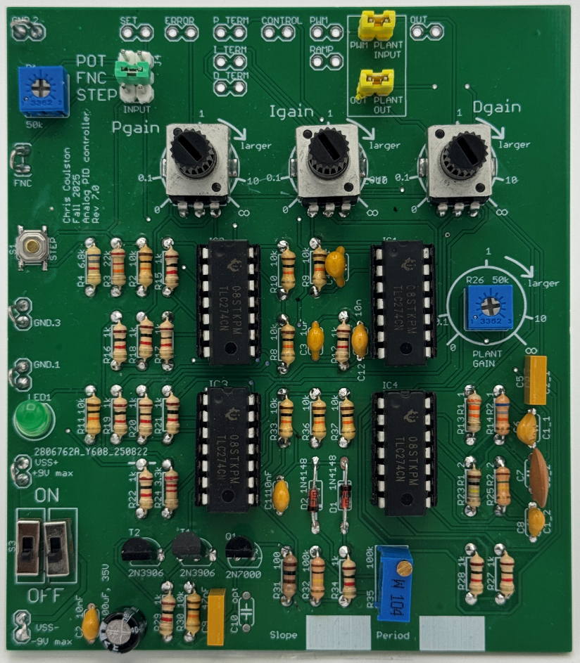
Figure 2: An assembled PID Controller board. The headers at the top of the board provide access to the values of the PID control loop using an oscilloscope.

